Chapter 7, Solution 44.

The switch in Fig. 7.111 has been in position a for a long time. At t = 0, it moves to position b. Calculate i(t) for all t > 0.

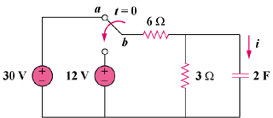

60 V

24V

Figure 7.111
For Prob. 7.44.

Solution
,

Using voltage division,
,

Thus,

